Lab 1

Tony Sommer

#1

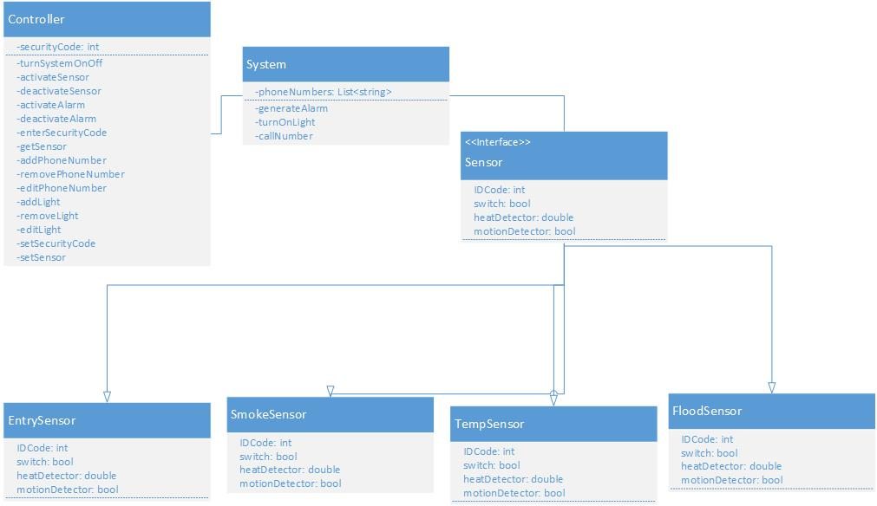

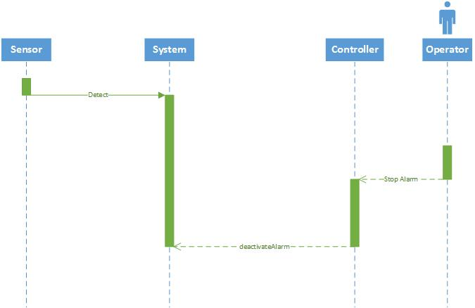

The way I designed the system, the Controller has access to the sensors, but has to go through the System itself. This allows for more flexibility, since it makes it easier to add additional Controllers if wanted.

2.

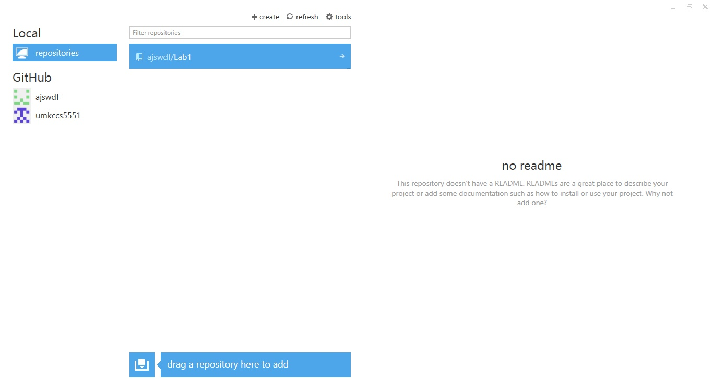

My GitHub account on the Windows GitHub.

3.

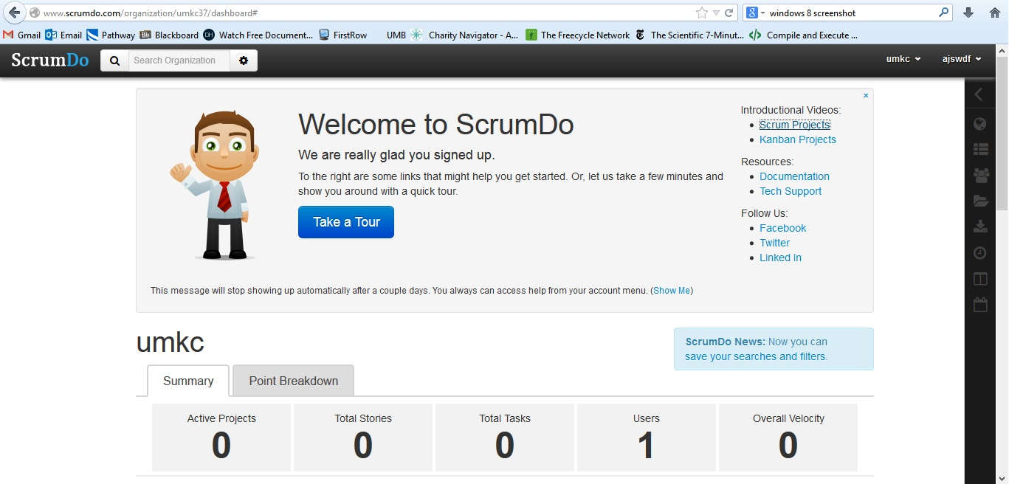

My ScrumDo account.

All pictures and Visio files are on my GitHub account at https://github.com/ajswdf/Lab1.